**A**

**Practical Assignment**

**New Age Life Skills**

Bachelor of Computer Application – I Sem



**RUNGTA INTERNATIONAL SKILLS UNIVERSITY**

**SESSION: 2025-26**

Mr Aditya kumar Submitted By :-

(Lecturer) Student name:- ADITYA KR.

Ref No :- 2025-01625

ERP ID :- RU-25-10089

**Submitted To :**

**RUNGTA INTERNATIONAL SKILLS**

**UNIVERSITY ,CG**

**SCHOOL OF COMPUTER SCIENCE ENGINEERING**

|  |  |  |  |
| --- | --- | --- | --- |
| **S.No** | **Name of Practical** | **Submission**  **Date** | **Remark** |
| 1. | Design a professional resume using template. |  |  |
| 2. | Create a career oriented Presentation with 7 slides using transitions and animation . |  |  |
| 3. | Create a social media poster for “DIGITAL AWARENESS WEEK “ using Canva. |  |  |
| 4. | Compose & send a professional email with an attachment as “you are applying for an internship, send email to HR with your resume attached”. |  |  |
| 5. | Design a complete Google Form survey and analyze responses.   1. Create a Google Form titled “Student Attendence Report”. 2. Include the following question types:    1. 5 MCQs    2. 1 Rating scale (1–5)    3. 1 Short answer    4. 1 Checkbox question 3. Customize the theme (header image + color). 4. Share the form link with 5 friends and collect responses.   Generate charts from responses and take screenshots of the analysis page. |  |  |
| 6 | Demonstrate the creation and management of your digital identity.   1. Create a social media profile (LinkedIn preferred). 2. Add a profile photo, short bio, skills, and education details. 3. Create a simple post about “My Learning   Journey in Digital Literacy.” |  |  |
| 7 | Using Google Drive or OneDrive:   1. Create a new folder named “Unit 3 Practical Work”. 2. Upload 3 different files (PDF, image, document). 3. Organize them in subfolders: Notes, Images, Assignments.   Share the main folder with your teacher with View Only permission. |  |  |
| 8 | Identify one real phishing email : A final-year student, Aman, receives a LinkedIn message saying:  “You are shortlisted for a Remote Software Developer role at Google.  Salary: ₹18 LPA.  Pay ₹2,499 as verification fee.  Limited seats. Pay now to confirm.”  ANSWER THE QUESTIONS :-   1. What type of cybercrime is happening here? 2. List 3 red flags that show it is a scam?   What should he do to verify if a job offer is real? |  |  |
| 9 | Create a Google Form Quiz with the following requirements:   1. Convert the form into a Quiz mode with automatic grading. 2. Add 5 MCQ questions, each carrying 2 marks. 3. Add 1 short answer question that requires manual evaluation. 4. Turn ON the setting:    1. *Limit to 1 response*    2. *Shuffle question order*    3. *Release marks after manual review* 5. Add a timer add-on (like form presenter) and set up a 10-minute time limit.   Finally, send the quiz link and view the response |  |  |
| 10 | Ask ChatGPT OR Google Gemini to generate a 100–120 word paragraph on:  “Is online learning better than offline learning for college students?”   1. Run the AI-generated text through Grammarly and any plagiarism-check tool. 2. Now manually search online to check if similar sentences exist on blogs or articles. 3. Identify 2–3 biased statements in the AI answer, such as:    * 1. Over-generalizations      2. One-sided opinions      3. Unproven claims 4. Rewrite the entire paragraph in a neutral and balanced way, using AI only for grammar suggestions. 5. Submit 3 screenshots:    1. Plagiarism check result    2. Grammarly suggestion page   Original AI paragraph vs your rewritten unbiased version |  |  |
| 11 | To compare AI-generated content with student-created content and understand limitations of AI.   1. Write a 100–150 word paragraph on the topic:   “Will AI replace jobs or change them?”  (This must be written by the student.)   1. Ask any AI tool (ChatGPT/Gemini/Copilot) to write the same topic. 2. In your practical copy, create a Comparison Table with the headings:    1. Human-Generated Content   AI-Generated Content |  |  |
| 12 | Create a new NotebookLM project titled: “My Chapter  Revision Notes.”   1. Upload multiple sources (any 2) such as:    1. PDF notes    2. Web articles iii. Text copied into NotebookLM 2. Ask NotebookLM to:    1. Create a combined study guide using all sources.    2. Generate flashcards for quick revision.    3. Create a concept map or explanation of the topic. 3. Manually check for:    1. Any incorrect facts    2. Repeated information iii. Missing important points 4. Attach 3 screenshots from NotebookLM:    1. Combined study guide   Flashcards iii. Concept map / explanation |  |  |

**Practical - 3**

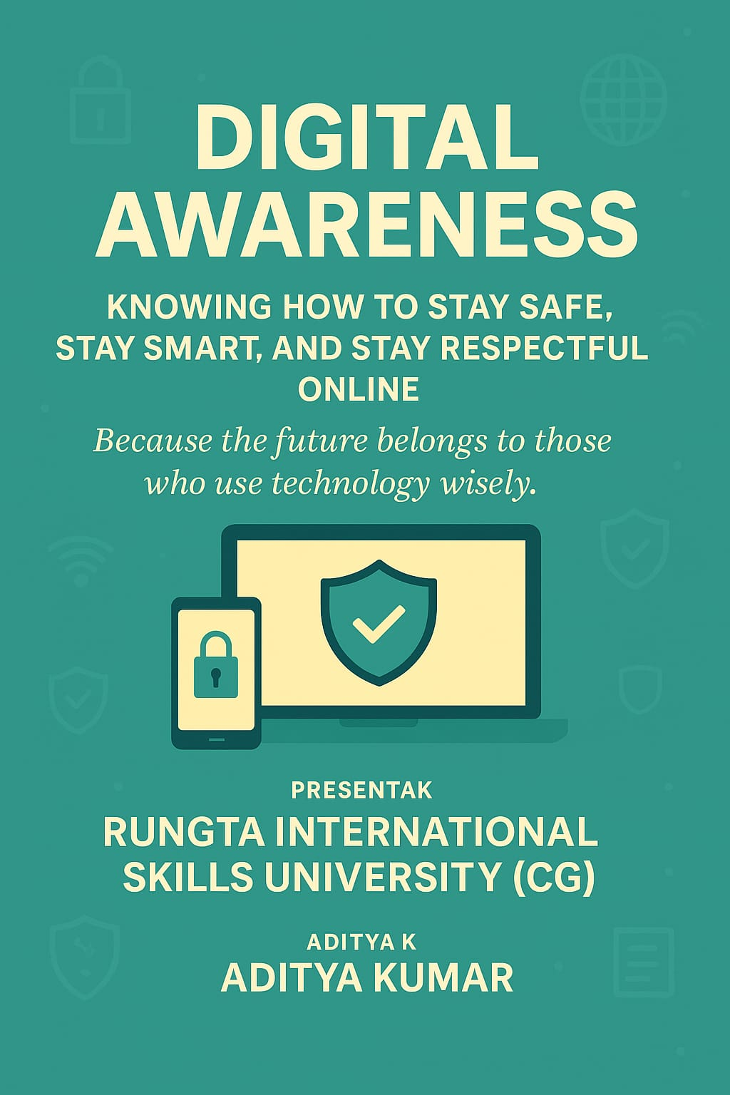

**Practical - 4**

4. Compose & send a professional email with an attachment as “you are applying for an internship, send email to HR with your resume attached”.

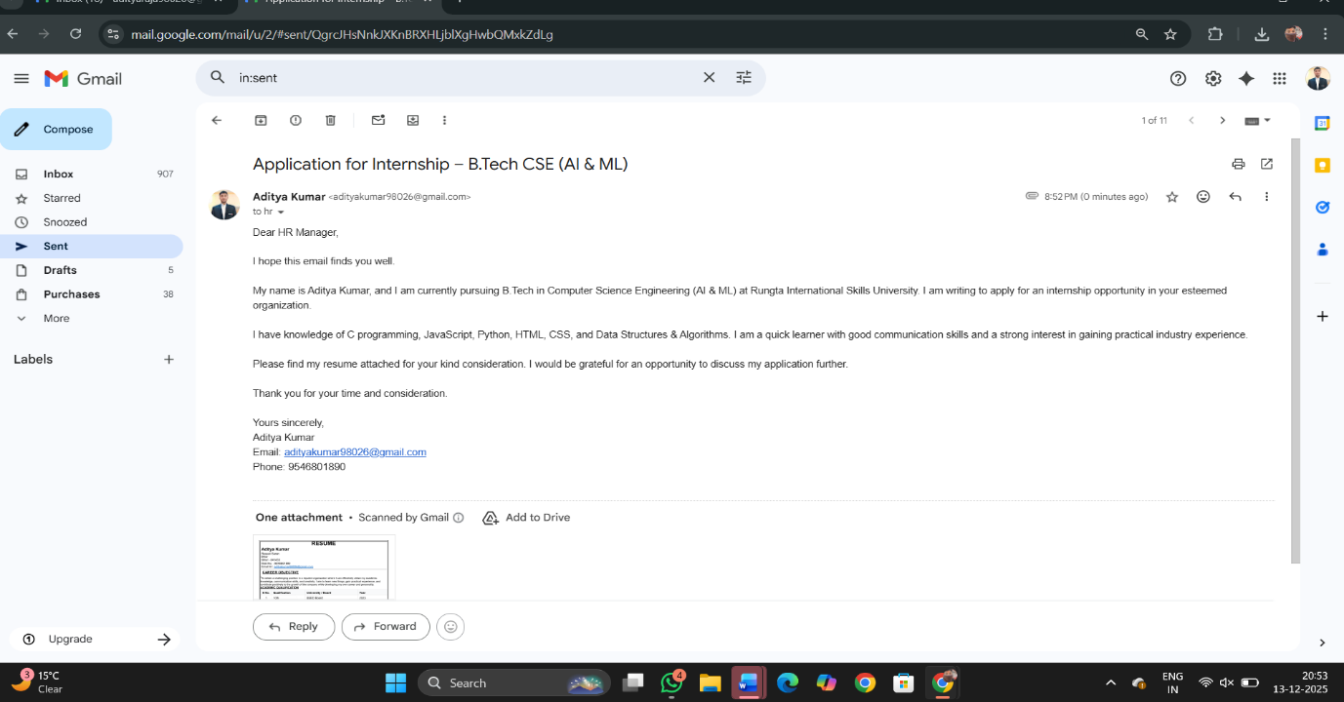

**Practical - 5**

4. Design a complete Google Form survey and Analyze responses.

1. Create a Google Form titled “Student Attendence Report”.
2. Include the following question types:
   1. 5 MCQs
   2. 1 Rating scale (1–5)
   3. 1 Short answer
   4. 1 Checkbox question
3. Customize the theme (header image + color).
4. Share the form link with 5 friends and collect responses.

Generate charts from responses and take screenshots of the analysis page.

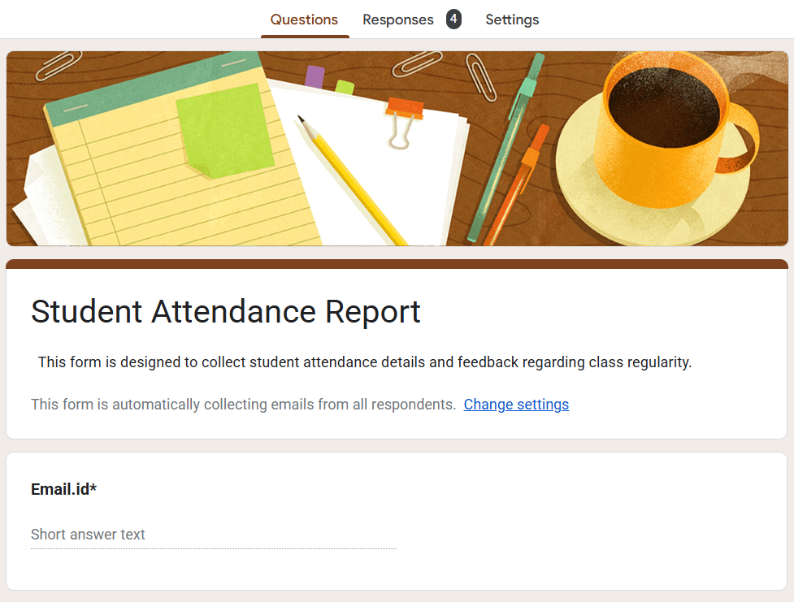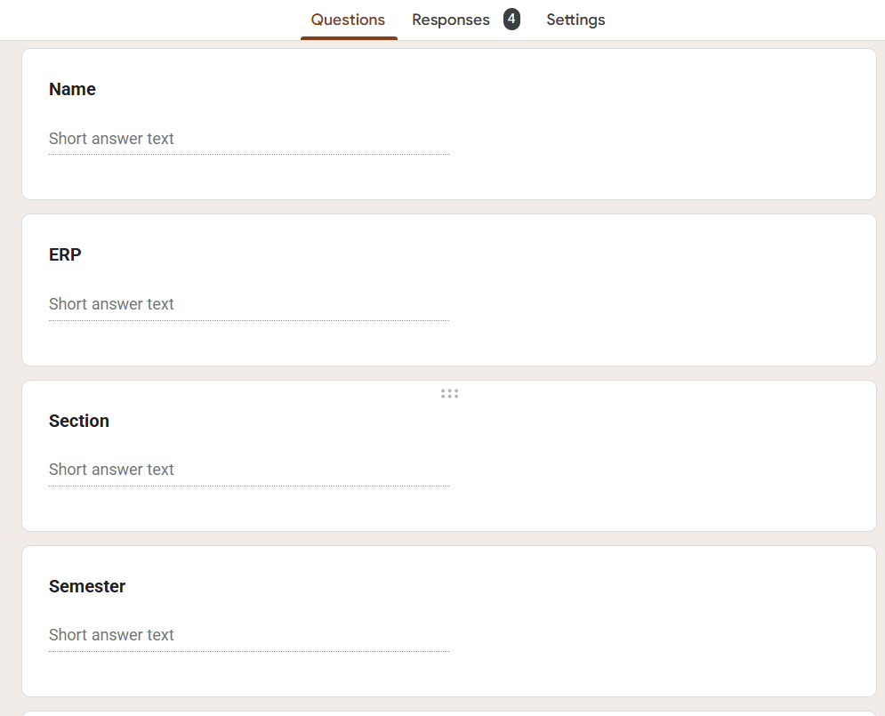

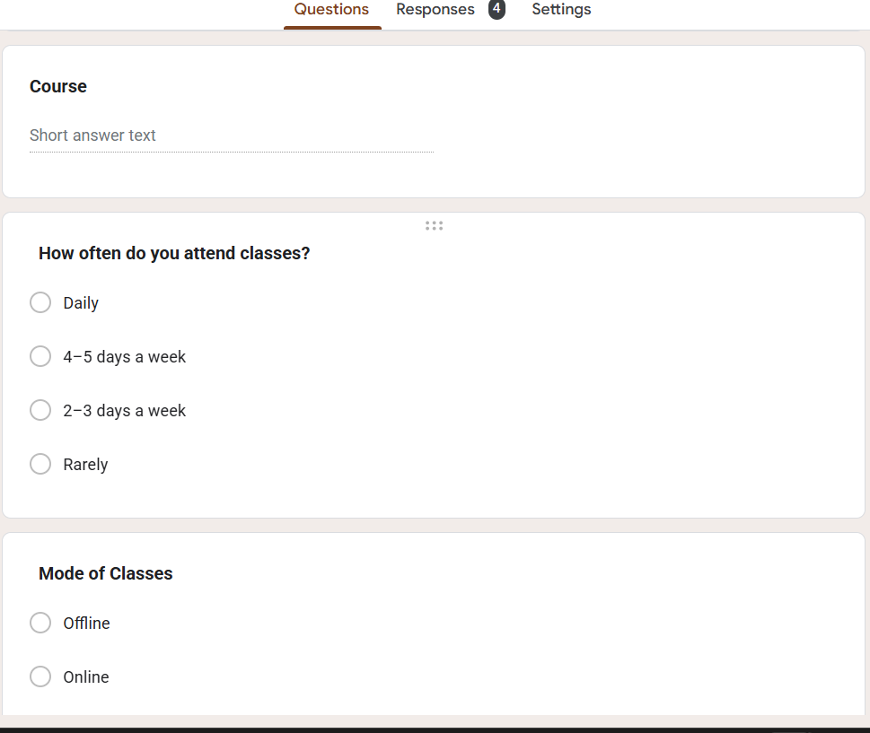

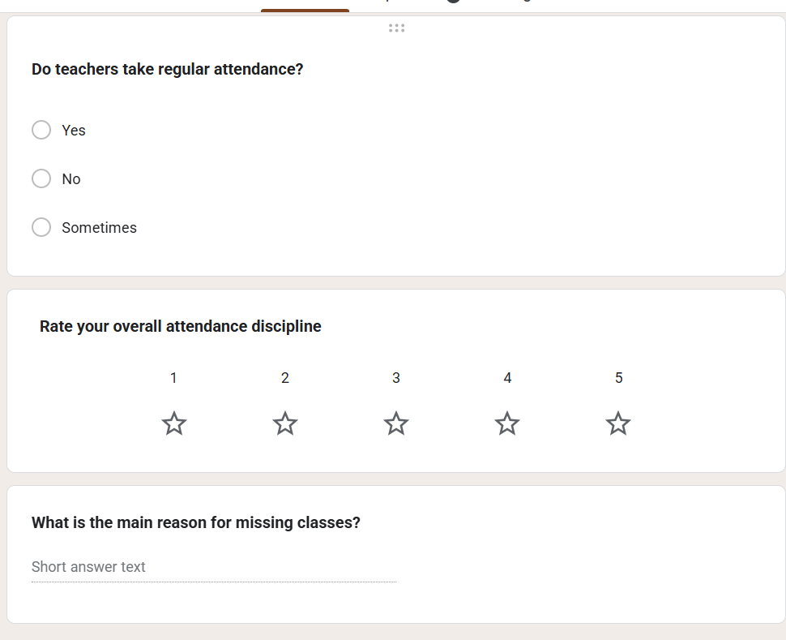

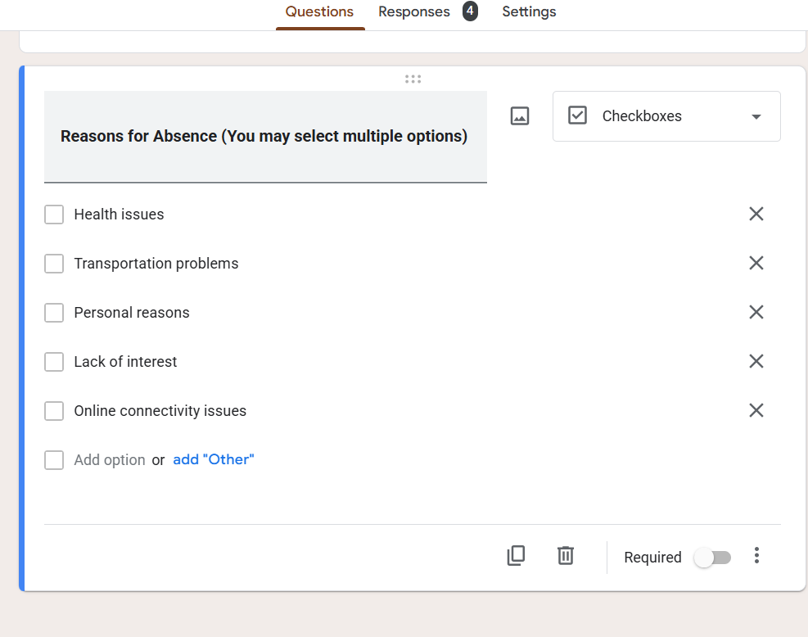

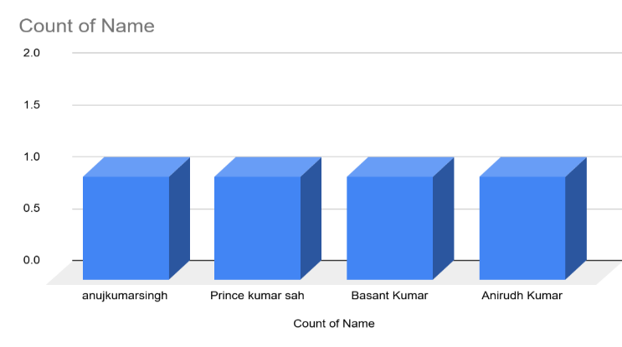 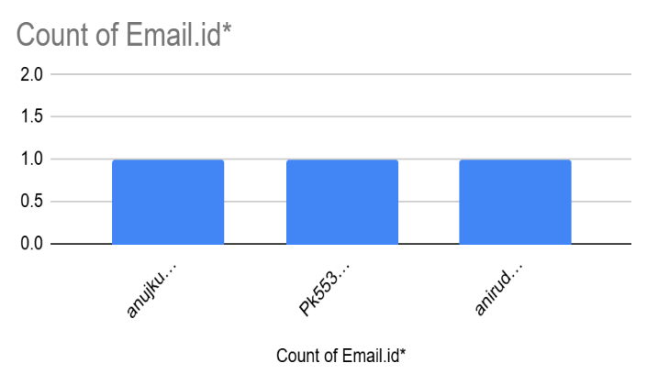

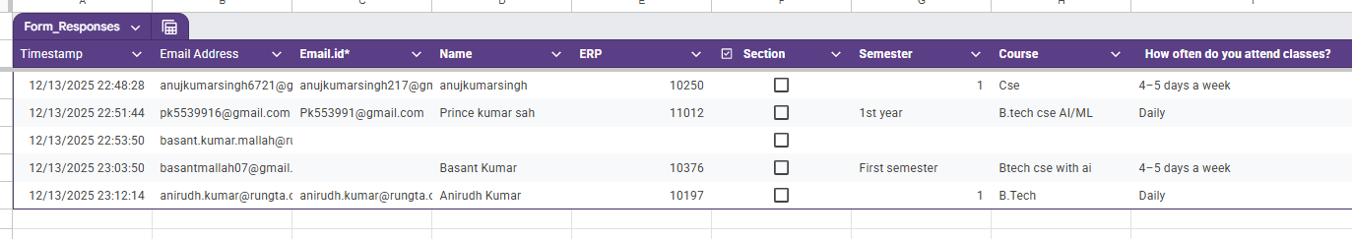

**Practical - 6**

6 . Demonstrate the creation and management of your digital identity.

Create a social media profile (LinkedIn preferred).

Add a profile photo, short bio, skills, and education details.

Create a simple post about “My Learning Journey in Digital Literacy.”

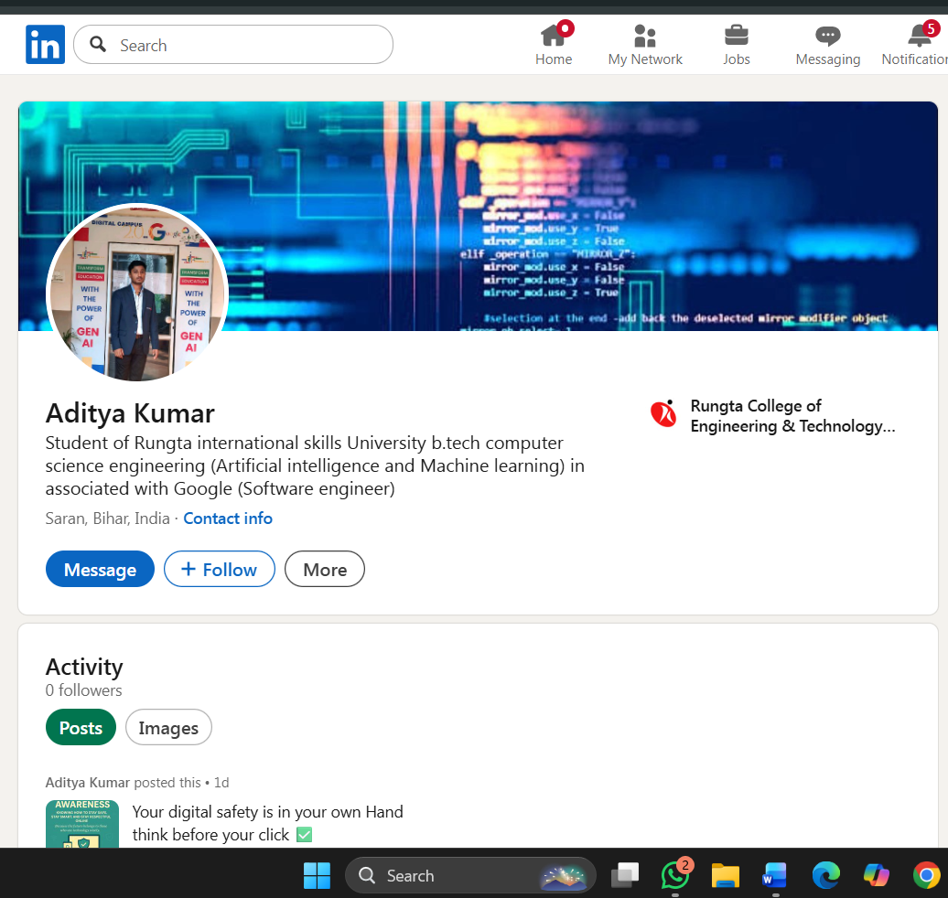

Practical 7:

Using Google Drive / OneDrive

Aim

To upload and organize files in cloud storage.

Objectives

• To manage files online

• To share files securely

Materials Required

• Google Drive / OneDrive account

Procedure

1. **Create folder “Unit 3 Practical Work”** Open Google Drive or your file manager and create a new folder named **“Unit 3 Practical Work.”** This folder will store all files related to the practical.
2. **Upload documents** Click the **Upload** option and select the required documents from your device.  
    The files will be saved inside the main folder for easy access.
3. **Create subfolders** Inside the main folder, create additional subfolders to categorize your documents.  
    This helps keep your work organized and easy to locate.
4. **Share main folder with View only** Right-click the folder, choose **Share**, and set the permission to **View only** for others.  
    This allows people to see the contents but prevents them from editing or deleting files.
5. 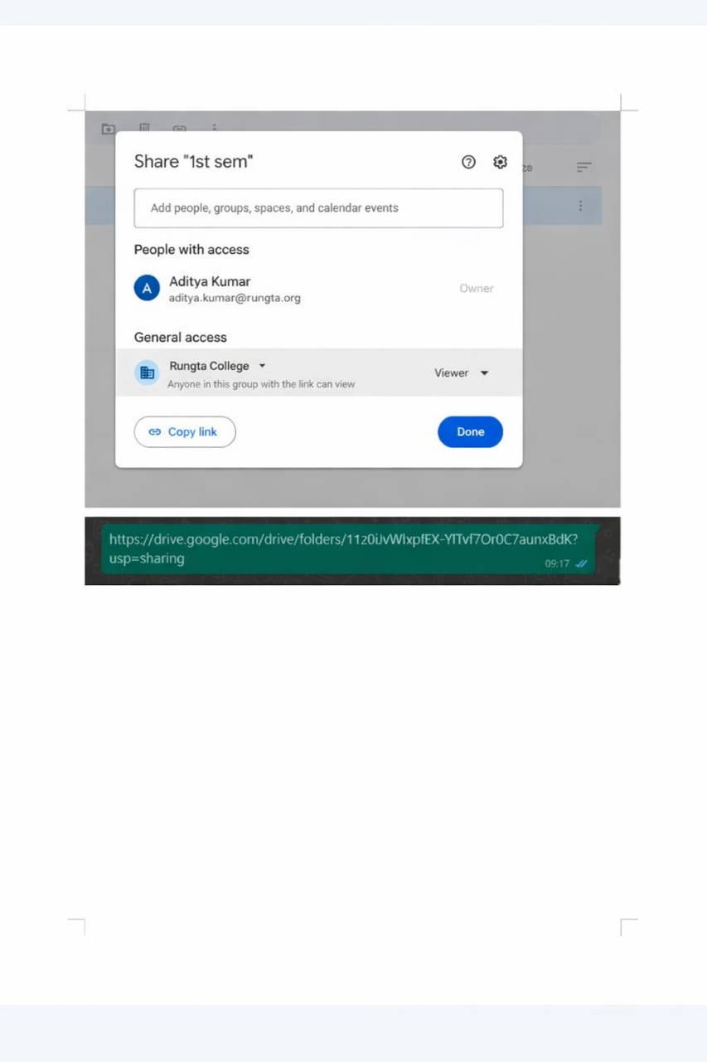



**Practical - 8**

**(8) Identify one real phishing email : A final-year student, Aman , receives a LinkedIn message saying**:

“You are shortlisted for a remote software Developer role at Google .

Salary: 18 LPA.

Pay 2,499 rupees as verification fee.

Limited seats. Pay now to confirm.”

**(a) What Type of Cybercrime Is Happening?**

**Answer:**

This is an example of a **Phishing Scam**, specifically a **Job Phishing / Online Recruitment Fraud**.

**Explanation:**

In this case, cybercriminals are impersonating a well-known company (Google) to gain the victim’s trust. By offering an attractive job role with a high salary, they attempt to emotionally manipulate the student. The main objective of this scam is to **extract money and possibly personal information** under the false pretense of job verification. This technique is commonly known as **phishing**, where fake messages are used to deceive individuals.

**(b) Red Flags That Indicate This Is a Scam**

The following warning signs clearly show that the job offer is fraudulent:

**1. Demand for Payment**

Legitimate companies never ask candidates to pay **verification, registration, or processing fees**. Asking for money is a major indicator of fraud.

**2. Unrealistically High Salary Without Interview**

Offering ₹18 LPA without any technical interview, assessment, or HR discussion is unrealistic and suspicious.

**3. Urgency and Pressure Tactics**

Phrases such as *“***Limited seats***”* and *“***Pay now***”* are commonly used in scams to force victims to act quickly without thinking.

**4. Lack of Official Communication**

The offer is made only through a LinkedIn message, with no official email from a verified company domain like @google.com.

**(c) What Should Aman Do to Verify Whether the Job Offer Is Real?**

To protect himself from fraud, Aman should follow these steps:

**1. Verify the Recruiter’s Profile**

He should check the sender’s LinkedIn profile for authenticity, including company affiliation, activity history, and professional connections.

**2. Visit the Official Company Website**

Aman should search for the job role on Google’s official careers page. Genuine job openings are always listed there.

**3. Never Pay Any Fee**

No real company charges candidates for job verification or onboarding. Any payment request should be treated as a scam.

**4. Confirm Through Official Email**

Legitimate recruiters contact candidates using official company email addresses, not personal or unverified accounts.

**5. Report the Scam**

The message should be reported to LinkedIn and ignored to prevent further harm.

**Conclusion:**

This case study highlights how job phishing scams target students by exploiting their career aspirations. By offering high-paying jobs and creating urgency, scammers trick victims into making quick decisions. Awareness, verification, and caution are essential to staying safe from such cybercrimes. Students should always remember that **no genuine job requires payment**.

**Practical - 9**

9.

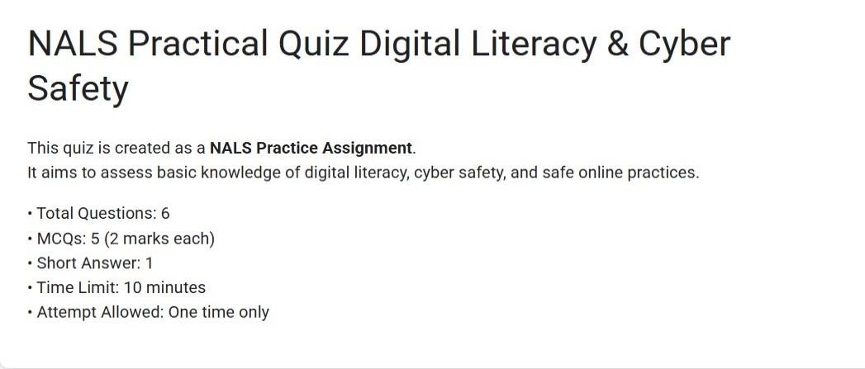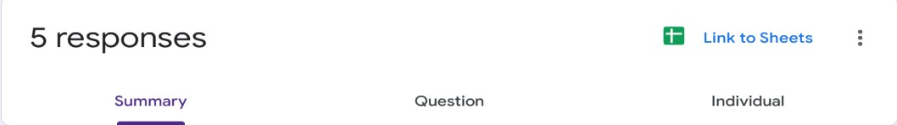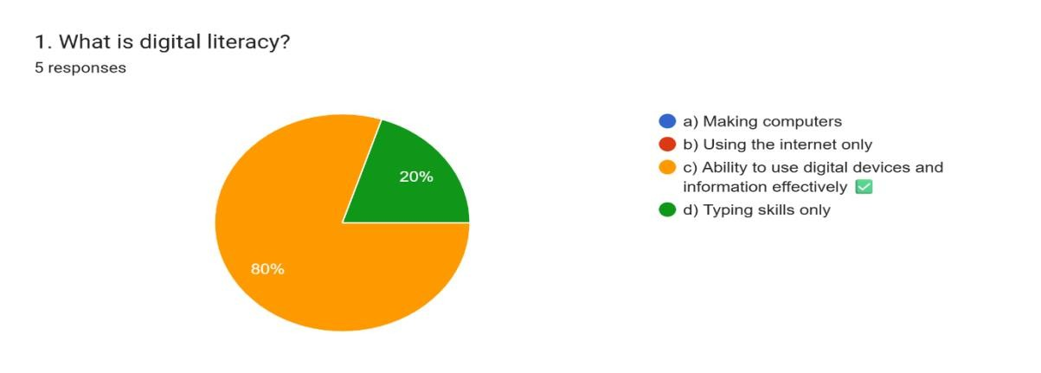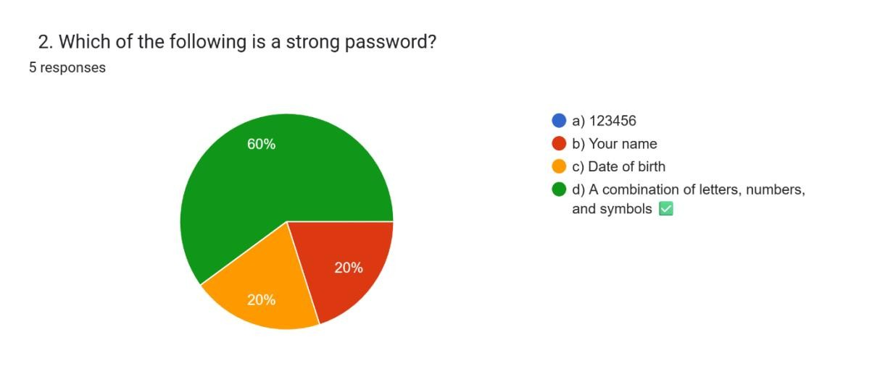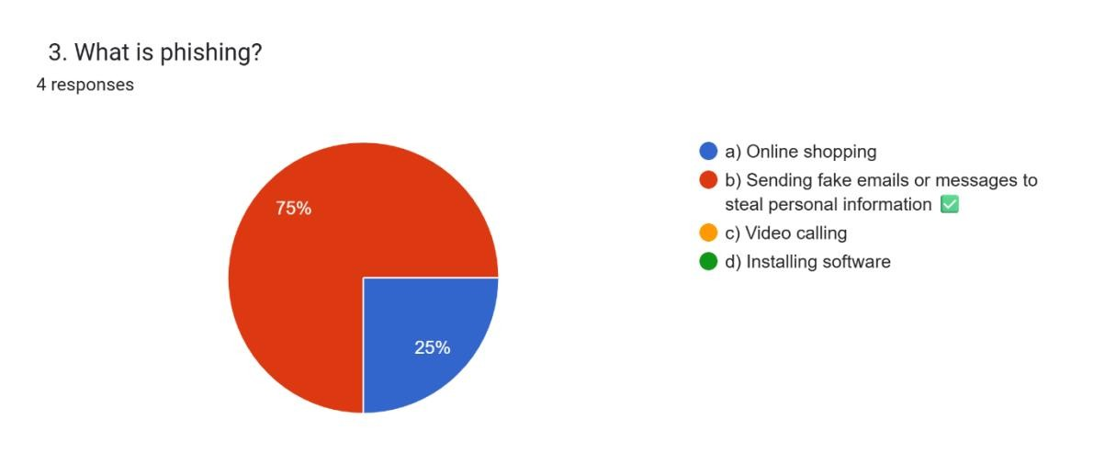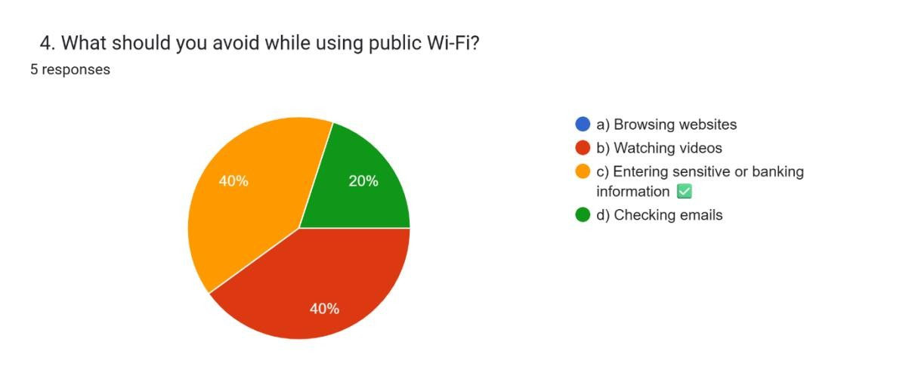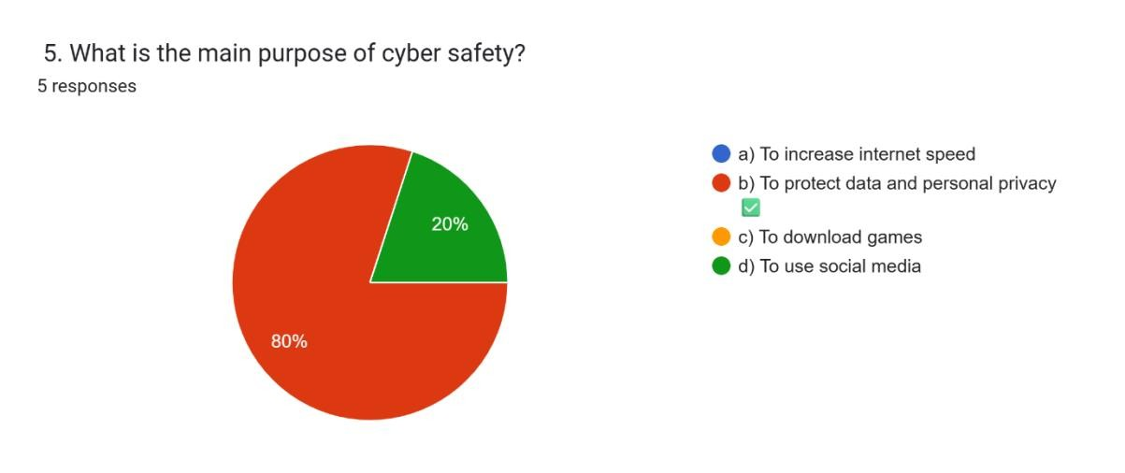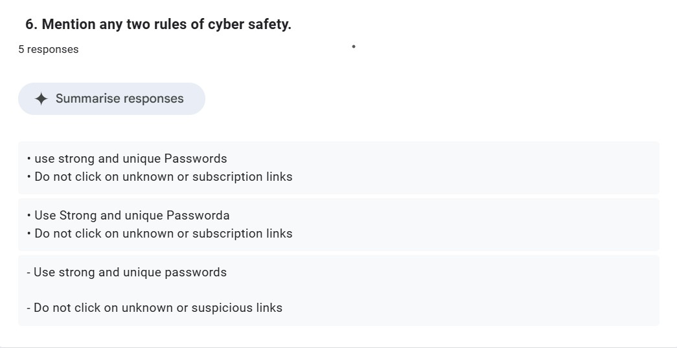

**10. Practical - 10**

**Is online learning better than offline learning for college students?**

**(a) Original AI-Generated Paragraph (100–120 words):**

# (Generated using ChatGPT)

Online learning is better than offline learning for college students because it offers flexibility, convenience, and easy access to digital resources. Students can attend classes from anywhere, which saves travel time and expenses. Recorded lectures help students revise topics multiple times. Online platforms also provide interactive tools and discussion forums that improve learning efficiency. Many students feel more comfortable asking questions in virtual classrooms. With the advancement of technology, online learning supports personalized education and self-paced study, making it an effective and modern alternative to traditional offline learning for college students*.*

1. **Grammarly & Plagiarism Check:** 
   * Grammar checked using **Grammarly**
   * Plagiarism checked using **online plagiarism checker**

1. **Biased Statements Identified** 
   * **Over-generalization:**

“Online learning is better than offline learning for college students.”

* + **One-sided opinion:**

“Making it an effective and modern alternative to traditional offline learning.”

* + **Unproven claim:**

“Online platforms improve learning efficiency.”

1. **Rewritten Neutral & Balanced Paragraph**

# (AI used only for grammar suggestions)

Online learning and offline learning both have advantages and limitations for college students. Online learning offers flexibility, digital resources, and recorded lectures that help in self-paced study. It can save time and reduce travel costs. However, offline learning provides face-to-face interaction, immediate feedback from teachers, and better classroom discipline. Traditional classrooms also help students develop communication and social skills. Therefore, instead of choosing one over the other, a balanced combination of online and offline learning may be more beneficial for college students.

**Screenshots Submitted**

**:**

•

Plagiarism check result

•

Grammarly suggestion page

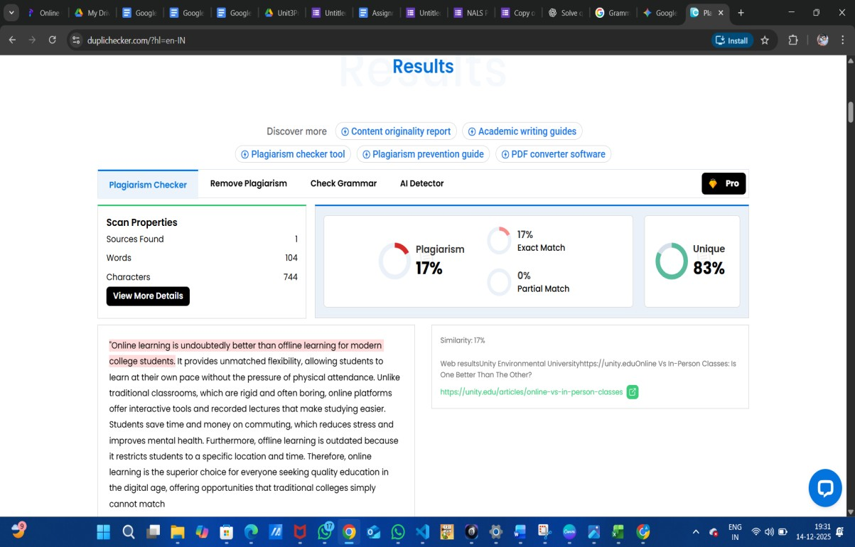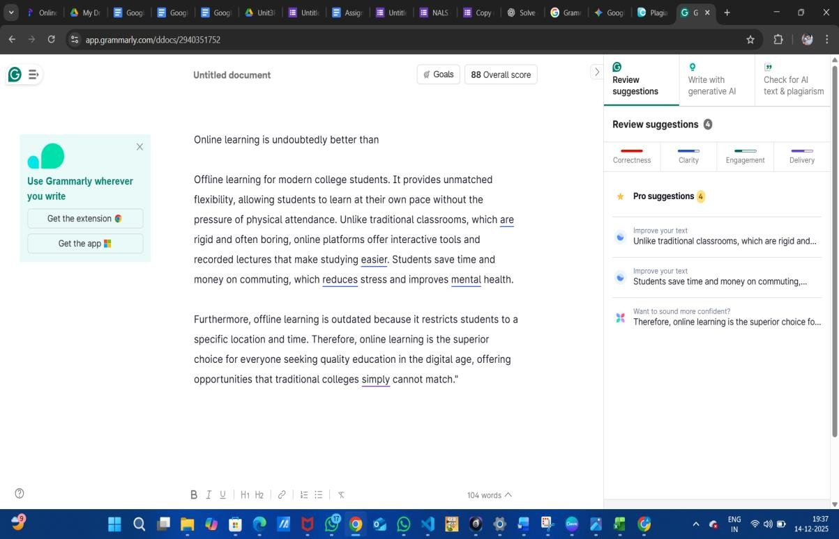

Practical 11

Compare AI vs Human Writing

Aim

To compare AI-generated content with student-created content.

Objectives

• To identify difference in writing

• To understand AI limitations

Materials Required

• AI tool

Procedure1. Write paragraph manually – Compose a paragraph yourself using your own ideas, wording, and structure on the selected topic.

2. Generate same topic using AI – Use an AI tool to produce another paragraph on the same topic for comparison.

3. Create comparison table – Organize both paragraphs side-by-side in a table to compare style, clarity, tone, and content differences.

**a) Human-Generated Content (Student-Written Paragraph)**

**Topic: Will AI replace jobs or change them?**  
*(100–150 words)*

Artificial Intelligence will not completely replace jobs, but it will change the way people work. Many routine and repetitive tasks can be done faster by AI, which may reduce the need for certain jobs. However, new opportunities will also be created that require human creativity, problem-solving, and decision-making skills. For example, AI can help doctors analyze medical reports, but human doctors are still needed to treat patients and make ethical decisions. Similarly, AI tools can assist engineers and programmers instead of replacing them. Workers will need to learn new skills to adapt to these changes. Therefore, AI should be seen as a tool that supports humans rather than a threat that removes jobs completely.

**(b) AI-Generated Content (Written by AI Tool)**

Artificial Intelligence is transforming the job market by automating tasks and improving efficiency across industries. While some jobs that involve repetitive work may be replaced by AI systems, many roles will evolve instead of disappearing. AI can handle data analysis, customer support, and basic decision-making, allowing humans to focus on more complex and creative responsibilities. Additionally, AI will create new job roles in fields such as machine learning, data science, and AI maintenance. The future workforce will require continuous learning and adaptability. Overall, AI is more likely to change the nature of jobs rather than eliminate employment opportunities entirely.

**(c) Comparison Table**

| **Human-Generated Content** | **AI-Generated Content** |
| --- | --- |
| Written using personal understanding and examples | Written using general knowledge and patterns |
| Simple language and natural flow | More formal and polished tone |
| Includes personal opinion and reasoning | Neutral and balanced explanation |
| May have minor grammar issues | Grammatically correct and structured |
| Reflects student’s thinking style | Reflects AI’s generic style |

**Practical 12**

**NotebookLM Project**

**Aim**

To create revision notes using NotebookLM.

Objectives

* To generate study guide
* To create flashcards

Materials Required

* NotebookLM

**Procedure**

1. **Create NotebookLM project** – Start a new project in NotebookLM to organize your materials and AI-generated outputs in one workspace.

1. **Upload two resources** – Add two documents or sources to the project so the AI can analyze and reference them.

1. **Generate study guide** – Use NotebookLM’s tools to create a structured study guide summarizing key concepts from the uploaded resources.

1. **Generate flashcards** – Automatically produce flashcards that highlight important facts, terms, or ideas for easier review.

1. **Review accuracy** – Carefully check the summaries and flashcards to ensure all information is correct and reflects the original resources.

1. **Take screenshots** – Capture screenshots of the study guide and flashcards to document your work or include them in your submission.

